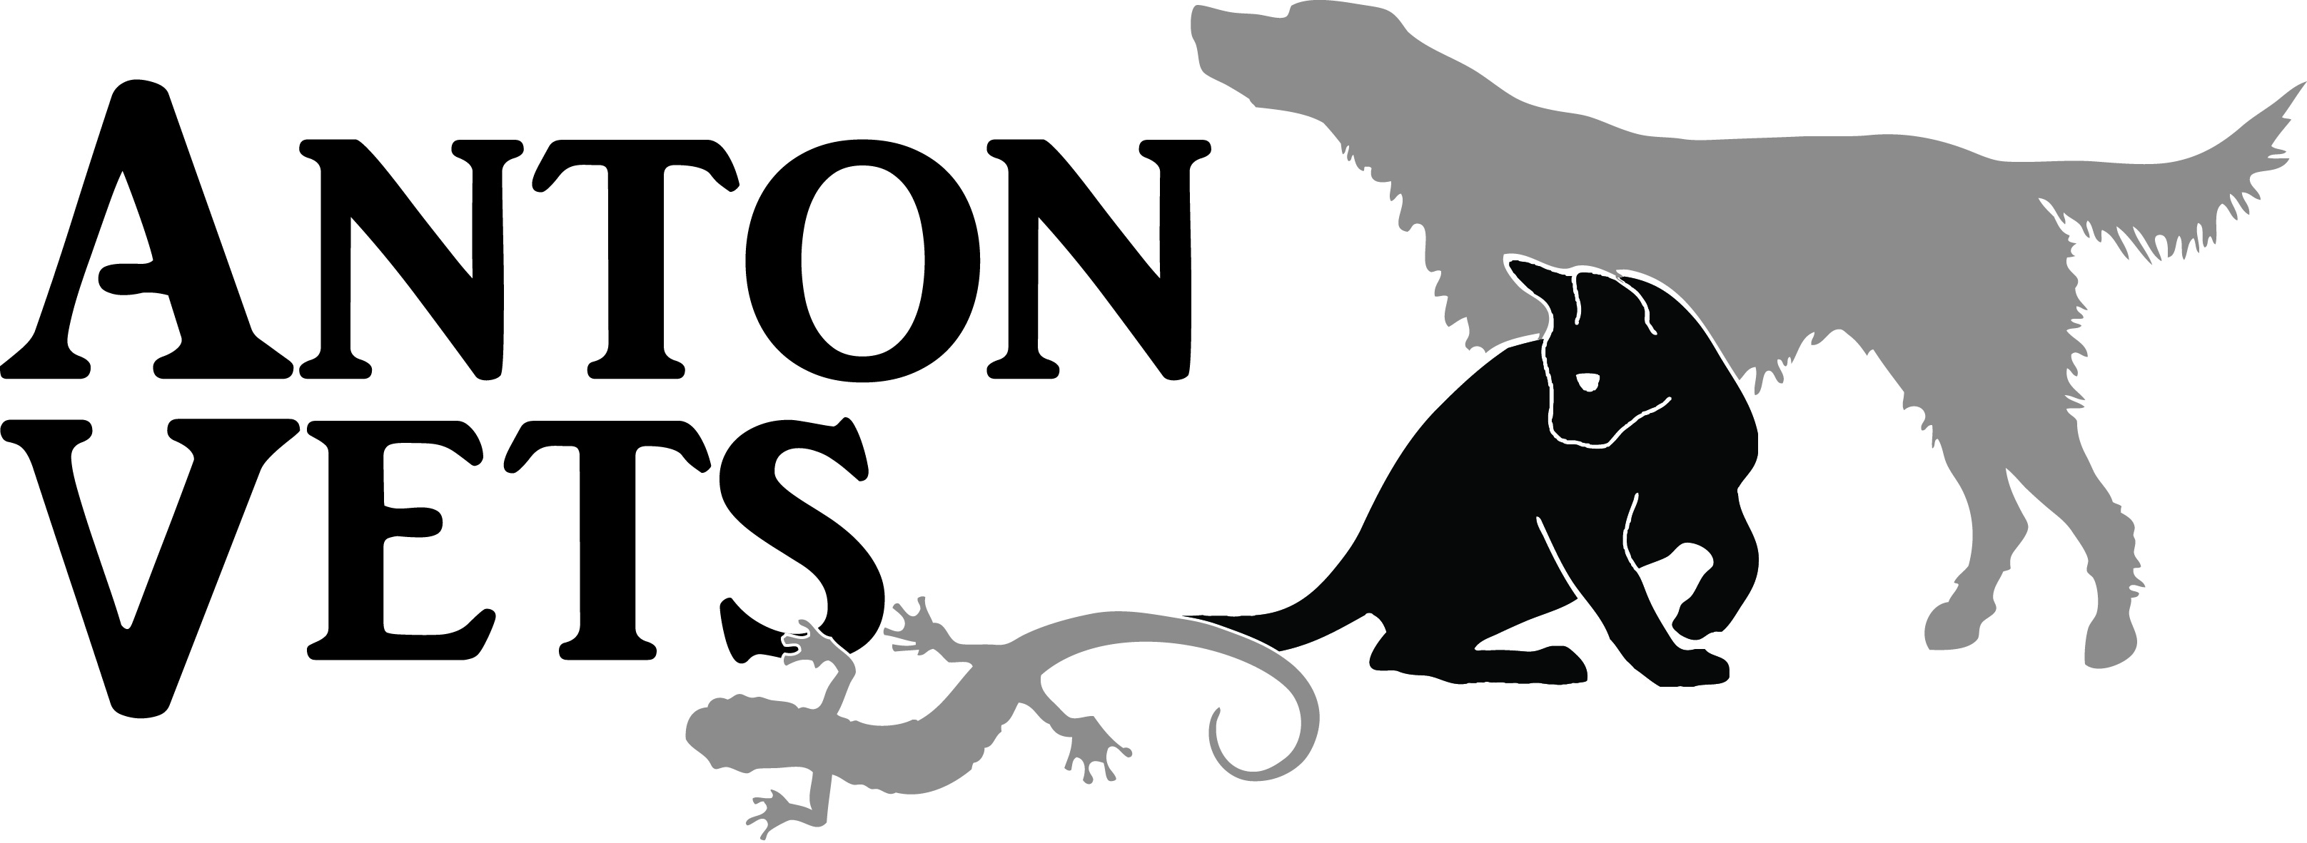

22/5/18

Due to the changes regarding the General Data Protection Regulations
(GDPR) we would like to make you aware of our updated privacy policy and information regarding the client data we collect and store.
The privacy policy will be maintained on our website (http://antonvets.co.uk/management/wp-content/uploads/2018/05/Privacy-Policy-Anton-Vets.pdf ) and a copy is available should you wish, by contacting us at office@antonvets.co.uk.
At Anton Vets we take your privacy seriously and will only use your
personal information to administer your account and to provide the products and services you have requested from us. However, from time to time we would like to contact
you with regards to your pets, account or other services we provide (e.g. vaccination reminders).
If you consent to us contacting you for this purpose please tick to say how you would like us
to contact you:
Post [ ] Email [ ] Telephone [ ]
Text message [ ] Automated call [ ]
I confirm that I have read and understood the privacy policy and consent to be contacted by Anton Vets by the methods detailed above.
NAME: ____________________________
ADDRESS:__________________________________________________________________________________________________________________________________________________________________________________________________________________________________________________________________________________________________________________________________
PREFERRED TEL NUMBER (if applicable):_________________________________

PREFERRED EMAIL (if applicable):________________________________________

DATE: ____________________________

